DFT investigation of green stabilizer reactions: curcumin in nitrocellulose-based propellants

Nathália M. P. Rosaa, Matheus Máximo-Canadasa, João Luís do Nascimento Mossri a, Rodrigo Leonard Barboza Rodrigues b, Jakler Nichele a,c and Itamar Borges Jr.* a,c

a Department of Chemistry, Military Institute of Engineering, Praça General Tibúrcio 80, Rio de Janeiro, Brazil;

b Institute of Chemical, Biological, Radiological and Nuclear Defense, Avenida das Américas 28705, Rio de Janeiro, Brazil;

c Department of Defense Engineering, Military Institute of Engineering, Praça General Tibúrcio 80, Rio de Janeiro, Brazil

*Corresponding author: I. Borges Jr., Email: itamar@ime.eb.br

**Abstract**

**Context**

Nitrocellulose, widely used in energetic materials, is prone to thermal and chemical degradation, compromising safety and performance. Stabilizers are molecules used in the composition of nitrocellulose-based propellants to inhibit the autocatalytic degradation process that produces nitrous gases and free nitric acids. Curcumin, (1E,6E)-1,7-bis(4-hydroxy-3-methoxyphenyl)-1,6-heptadiene-3,5-dione, known for its antioxidant properties and a potential green stabilizer, was investigated using Density Functional Theory (DFT) focusing on its interaction with nitrogen dioxide. Two mechanisms were analyzed: aromatic ring nitration and free radical formation. The results indicate that nitration of the aromatic ring of curcumin and the formation of a curcumin-based free radical are viable. The computed Gibbs free activation energy (∆‡*G*°) and the activation enthalpy (∆‡*H*°) for two different temperatures, 298.15 K (room temperature) and 363.15 K (typical temperature in aging tests), are respectively 43.64 kcal/mol and 44.78 kcal/mol for the first reaction, and 31.54 kcal/mol and 35.31 kcal/mol for the second. The radical-based mechanism favors improved kinetics. These findings demonstrate curcumin’s potential as an effective stabilizer, providing comparable performance to traditional compounds with lower environmental impact.

**Methods**

DFT calculations were carried out using Gaussian 09 and Orca 5.0.1 packages. The ωB97M-V, B3LYP, and M062X functionals were employed with the 6-311+G(d) and 6-311G(d) basis sets. Solvent effects were modeled using the Conductor-like Polarizable Continuum Model (CPCM) and Solvation Model based on Density (SMD) continuum solvent models. Thermochemical data were computed using the same levels of calculation.

**KEYWORDS**

Green stabilizer; nitrocellulose-based propellants; Density functional theory (DFT); Decomposition mechanisms; Natural products; Free radical reaction

**ORCIDs**

Nathália M. P. Rosa - <https://orcid.org/0000-0002-3915-0036>

Matheus Máximo-Canadas - <https://orcid.org/0009-0003-3029-1902>

João Luís do Nascimento Mossri - <https://orcid.org/0000-0002-3265-3896>

Rodrigo Leonard Barboza Rodrigues - <https://orcid.org/0000-0002-6048-8103>

Jakler Nichele - <https://orcid.org/0000-0003-3046-8459>

Itamar Borges Jr - <http://orcid.org/0000-0002-8492-1223>

**STATEMENTS & DECLARTIONS**

**Funding**

The authors thank the support for this research from the Brazilian agencies CNPq (research grants 304148/2018–0 and 409447/2018–8) and FAPERJ (research grants E-26/201.197/2021, E-26/211.046/2021 and E-26/201.251/2022).

**Competing interests**

I. B. is an associate editor of the Journal of Molecular Modeling. The authors do not have additional financial or non-financial interests to disclose.

**Authors contributions**

*Nathália Magalhães Paixão Rosa* **-** Data curation, Formal Analysis, Investigation, Software, Visualization, Writing and revision.

*Matheus Máximo-Canadas -* Data curation, Formal Analysis, Investigation, Software, Visualization, Writing and revision.

*João Luís do Nascimento Mossri* - Data curation, Formal Analysis, Investigation, Software, Visualization, Writing – original draft

*Rodrigo Leonardo Barboza Rodrigues* - Conceptualization, Data curation, Formal Analysis, Methodology.

*Jakler Nichele -* Conceptualization, Data curation, Formal Analysis, Methodology, Supervision, Validation, Visualization, Writing - review & editing

*Itamar Borges Jr.* - Conceptualization, Data curation, Formal Analysis, Funding Acquisition, Methodology, Project administration, Resources, Supervision, Validation, Visualization,; Writing - review & editing

**Data availability**

The datasets generated during and/or analyzed during the current study are reported in the additional Supporting information of this work. They are also available from the corresponding author on reasonable request.

**Pre-print**

A version of this paper was deposited as a pre-print in ChemRxiv and can be found at:

<https://doi.org/10.26434/chemrxiv-2023-dwwdt>

# 1 Introduction

Stabilizers are essential raw materials employed in nitrocellulose-based propellants aiming to inhibit their autocatalytic degradation. The degradation reactions, which reduce the propellant shelf-life, occur under ambient storage circumstances [1], thus compromising the ballistic performance [2]and the safety in handling and storage. Another issue concerning propellants is the increasing importance of dealing with environmental and health hazards, which led to the development of new stabilizers to replace traditional ones [3,4].In particular, curcumin is a promising natural product as a green stabilizer [5]. Other potential green stabilizers include guaiacol [6], some phenols, trimethoxy-aromatic, guaiacol-curcuminoids, ionone derivatives, and tocopherol (vitamin-E).

Different nitro compounds, including toxic substances, are formed during nitrocellulose (NC) degradation [7,8]. The first step in this process is the cleavage of the O-NO2 bond in the nitrate ester group. Afterward, the nitrogen dioxide reacts with other environmental molecules, generating different nitro compounds. These products react back with NC, thus accelerating the degradation, which is enhanced by moisture and temperature [1,5,9]. At the same time, they also react with the stabilizer molecules in a competing process, which consumes the nitro products of degradation. Consequently, the effective shelf-life of NC-based propellants is typically ten years [10], although it can reach up to 20 years [2].

Nowadays, the most used propellant stabilizers are diphenylamine (DPA), methyl centralite, ethyl centralite, akardite I, and akardite II [2,5,7,11-13].Diphenylamine, ethyl centralite, and akardite II generate toxic products with mutagenic potential during the stabilization process [7]. To avoid or reduce these risks, developing green stabilizers, less dangerous substances, is eagerly sought [9]. To be useful, green stabilizers must be easily produced, allow safe handling, be abundant in the international market, have low cost, have equal to or superior performance in stabilizing compared to the traditional ones, and possess a minor environmental impact [5,12].

Curcumin, (1E,6E)-1,7-bis-(4-hydroxy-3-methoxyphenyl)-hepta-1,6-dien-3,5-dione or C21H20O6, is the main curcuminoid of *Curcuma longa*, being one of the most available and inexpensive green stabilizers. Its effectiveness as a stabilizer was assured by the results of heat flux microcalorimetry for single-base and double-base propellants following the STANAG-4582 protocol, which includes standards to be achieved by a substance to be accepted as a stabilizer. There are several other methods to assess the stability of a propellant, but they usually include artificial aging employing high temperatures [5,9]. Curcumin also presents antitumor, antioxidant, anti-mutagenic, and anticarcinogenic properties [5,14]. Part of the curcumin molecule (Figure 1) has a guaiacol-type structure [6], which suggests similar behavior and mechanism.

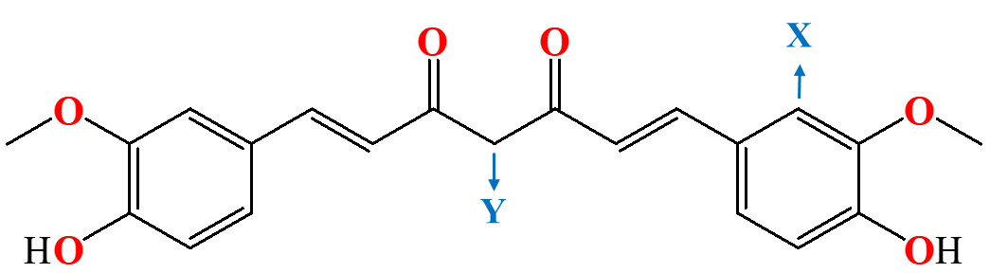

**Figure 1.** The structural formula of curcumin with the explicit indication of the C and O atoms. Hydrogen atoms are not shown. The positions labeled X and Y are the sites for reaction with NO2.

Investigations of curcumin as a stabilizer are recent [3,5], in contrast with the most used [2,7,11-13,15]. Even for the widely used DPA, the stabilization process is complex, and the nature of the captured nitro compounds might be considered “speculative” in some sense [8,16,17]. For curcumin, the reactions are even less known. This substance is supposed to react with nitro compounds, such as NO2, HNO2, and HNO3 [16], and the lack of nitrogen in curcumin avoids the formation of nitroso-amines as byproducts of *N*-nitrosation reactions, which are carcinogenic agents [5]. Therefore, C-nitration reactions are more likely for curcumin, contrasting with DPA, methyl centralite, ethyl centralite, akardite I and akardite II [16,18].

C-nitration of aromatic rings usually involves the nitronium cation NO+ and the sulfonate anion [19]. The NC stabilization process is kinetically unfavored due to the neutral pH under storage [15]; however, it is thermodynamically feasible. Additionally, the central carbon can lead to reactions similar to *N*-nitrosations that occur with DPA [18]. For curcumin, the mechanism involves two coexisting radical structures in tautomeric equilibrium. The electronic delocalization of the unpaired electron is distributed around the central atom and one of the carbonyl oxygen. It contributes to forming a sufficiently stable reactant (Figure 2), which turns viable a posterior nitration. Regarding the degradation processes, there are results related to the NC decomposition and determination of enthalpies and free energies for stabilization reactions with DPA [8,16] and curcumin [20]. Still, no work was found presenting curcumin transition states and activation energies for degradation.

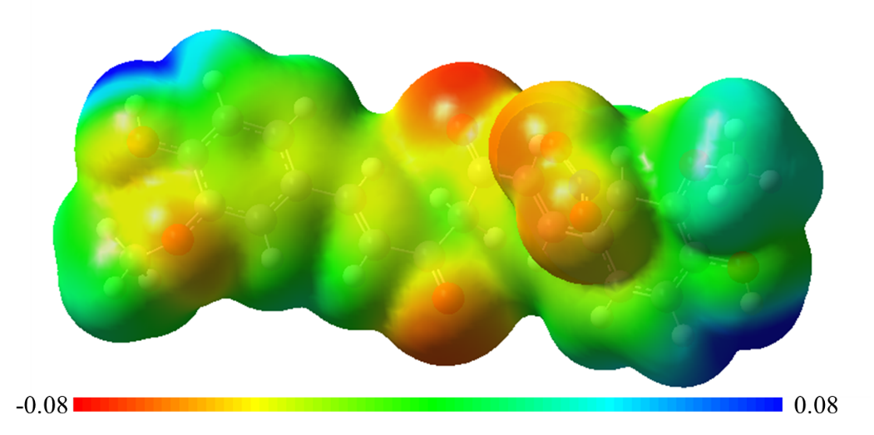

**Figure 2.** Electrostatic potential (in Hartrees) of the radical structure of a curcumin molecule after a hydrogen release and the formation of the nitrous acid sub-product. From red to blue, the potential scale ranges from negative (red) to positive (blue).

Density Functional Theory (DFT) calculations are widely applied in predicting reaction mechanisms of organic molecules due to their balance of accuracy and computational efficiency. In propellant stabilization, DFT enables a detailed analysis of reaction pathways and activation energies, which are critical factors for understanding the effectiveness of potential stabilizers [21-23]. By modeling molecular interactions and obtaining thermodynamic and kinetic data, DFT allows for predicting how green stabilizers, such as curcumin, interact with reactive nitrogen compounds produced during the degradation of nitrocellulose. This level of detail is essential for assessing the feasibility of new stabilizers and their impact on the longevity and safety of propellants, supporting a more sustainable and safer approach in the formulation of these energetic materials.

Our group has employed quantum chemistry simulations based on the DFT and ab initio wave functions to investigate the impact sensitivity of energetic materials [24-32] and excited states [33-38].In this work, we employ DFT to investigate the mechanisms related to the stabilizing role of curcumin in NC. Two different temperatures, 298.15 K (room temperature) and 363.15 K (a typical temperature of accelerated aging tests) [39] were examined. Two reactions of curcumin with NO2 at the positions C-X and C-Y (Figure 1), whose products are indicated in Figure 3, were studied.

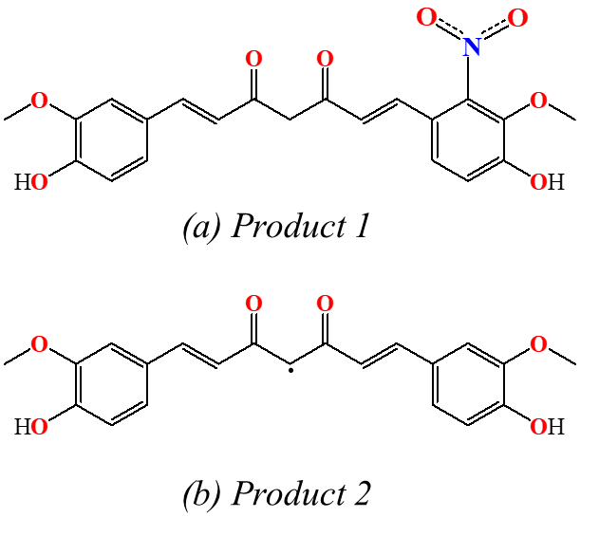

**Figure 3.** Possible products from the curcumin nitration for reactions (a) at the carbon X and (b) at the carbon Y, as indicated in Figure 1.

# 2 Methodology

DFT calculations were carried out with the Gaussian 09 [40] and Orca 5.0.1 [41] software packages. The B3LYP exchange-correlation functional [42,43] was employed for all atoms to obtain the transition states (TS) structures, compute intrinsic reaction coordinates (IRC), and the related equilibrium structures. Harmonic frequency calculations were conducted using the same methods to confirm the presence of negative frequencies for transition state (TS) structures and non-negative frequencies for reactant and product structures. This functional was chosen because it is widely used, has a low computational cost, and has good accuracy for converging molecular geometries and other properties.

It is essential to highlight that the B3LYP functional are built from different local density approximations (LDA) in Gaussian, which uses VWN(III), and in Orca, VWN(V), which eventually may lead to slight differences. Thermodynamic calculations [44]wereperformed for the 298.15 and 363.15 K temperatures.In the Orca calculations, the resolution of identity approximation was used to reduce the computational cost of computing the Coulomb and direct exchange integrals [45-47].

To evaluate the influence of different DFT functionals and the inclusion of diffuse basis functions on the computed thermodynamic data, we used B3LYP, M06-2X, and ωB97M-V functionals, the latter implemented only in the Orca program package. According to Bursch et al. [48], the ωB97M-V [49] functional performs exceptionally well predicting energy barriers, while M06-2X [50] is widely used and demonstrates good accuracy. To improve data comparison, we used the 6-311G(d) and 6-311+G(d) basis sets to assess the effect of including diffuse functions.

The Conductor-like Polarizable Continuum Model (CPCM) [51] (Gaussian 09) and Solvation Model based on Density (SMD) [52] (Orca) continuum solvent models were used. Both were employed to simulate the NC environment in the calculations, referred to as NCL for “nitrocellulose lacquer”. The static dielectric constant was set to 7.0, as suggested by Itkis and Bohn [16]. Other data besides the static dielectric constant were not found in the literature; hence, the dynamic dielectric constant, surface tension at the interface, and Abraham’s hydrogen basicity parameters were chosen by considering the compounds with the static dielectric constant in the range of 6.7 to 7.3, as suggested by Winget et al. [53] and done in our previous work on DPA [8]. The lowest values were selected for the dynamic dielectric constant and Abraham’s hydrogen basicity. Considering the NC polymeric properties, the highest value was for the surface tension at the interface. Therefore, the dynamic dielectric constant was set to 1.85341, and the surface tension at the interface to 60.62 cal.mol*−*1 Å–2, and Abraham’s hydrogen basicity to 0.48. Abraham’s hydrogen acidity, carbon aromaticity, and electronegative halogenicity were set to zero for the calculations because nitrocellulose is not aromatic, a halogen atom, or a very acidic hydrogen. These parameters were sufficient to describe the nitrocellulose properties in the calculations.

Thermochemical data, including the Gibbs free activation energy (∆‡*G*°) and the activation enthalpy (∆‡*H*°), were computed considering the single-step mechanisms depicted in Figure 4. The first mechanism (R1) describes the nitration of the curcumin aromatic ring, resulting in Product 1 and a free radical hydrogen. The second mechanism (R2) corresponds to the capture of the hydrogen by NO2 of the central carbon, resulting in Product 2 and HNO2.

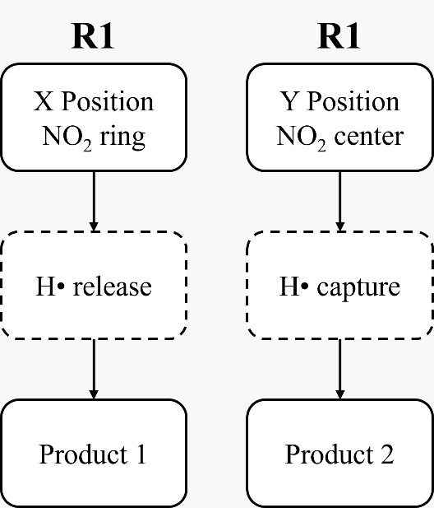

**Figure 4.** The flowchart of calculations for the investigated mechanisms resulting in Product 1 and Product 2 (Figure 3) was generated from reactions of curcumin with NO2 correspondingto mechanisms R1 and R2.

# 3 Results and discussion

Our calculations elucidated the mechanisms R1 and R2 (Figures 4 and 5) for the reaction of curcumin with NO2, which generates Product 1 (P1) and Product 2 (P2), respectively. R1 is the nitration of the aromatic ring, and R2 is the multi-step mechanism with a radical intermediate similar to the *N*-nitrosation of DPA. The R1 mechanism can be more relevant in the NC stabilization than R2 for two reasons. First, R1 can occur twice for each molecule because it has two aromatic rings, contrasting with R2, which can happen only once. Second, because curcumin does not capture a nitro compound in R2, the nitro compound involved the transformation from NO2 to HNO2 can still react in an NC degradation autocatalysis. Even if we considered a subsequent reaction in multi-step R2, the whole mechanism would be less relevant than R1. This is because the mechanism comprising less elementary reactions is more likely to occur (in our case, R1) if we assume similar energy barrier heights for each step [18].

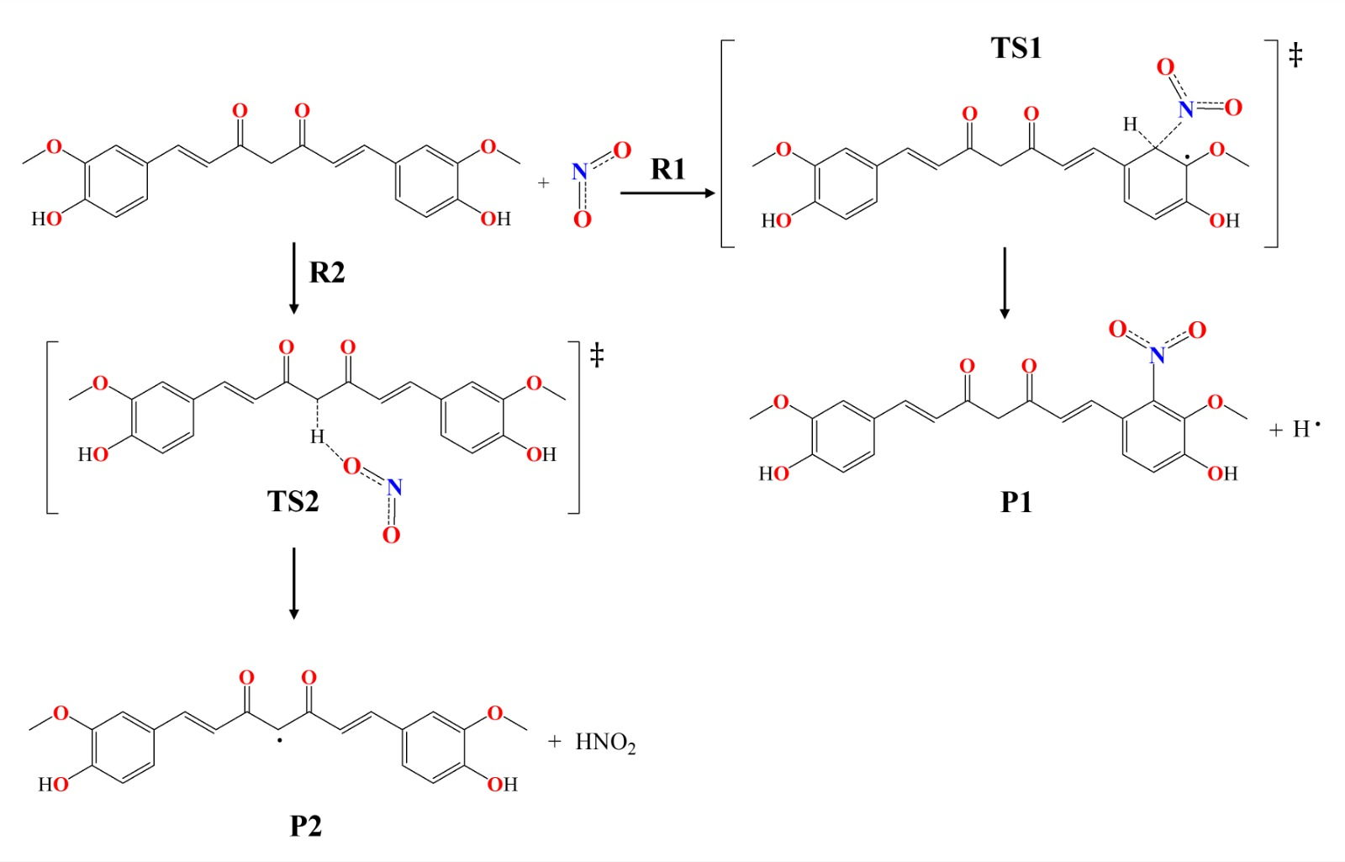

**Figure 5.** The mechanism for: (a) the aromatic ring nitration in curcumin (R1) and; (b) the hydrogen removal from the central carbon (R2).

Although the temperature does not affect the converged geometries, limitations in the LDA part of the functional could affect the results [54]. Nevertheless, few results differed slightly (see Figure 1S and Table 1S in the Supplementary Material). Among the transition state geometries in mechanism R1 (ring nitration), the most significant difference occurs in the angle between the breaking and forming bonds, less than 0.3%. For R2 (hydrogen removal), the values of the forming bond also differ by less than 0.3%. Therefore, we found that the differences due to different LDA forms in the exchange-correlation functional are negligible.

During a chemical reaction, the molecular orbitals of the involved species are modified, so we analyzed the frontier molecular orbitals in our reactions to understand these changes [55]. The analysis focused on the highest occupied molecular orbital (HOMO), the lowest unoccupied molecular orbital (LUMO), and the orbital immediately below the HOMO (HOMO-1), as inner orbitals can contribute a weak bonding character to the involved bonds [56]. For Reaction 1 (Figure 6(a)), we found a higher electron density in the region of position X on the curcumin molecule in the HOMO and LUMO orbitals, indicating electron transfer at this position. The HOMO-1 orbital, however, does not show bonding character at position X. In the transition state (TS) structure, the electron density increase in the LUMO over the C-H bond at position X, with the emergence of an anti-bonding interaction, indicating the weakening of this bond. In the TS, the HOMO-1 orbital displays a weak bonding character in forming the C-NO₂ bond and the anti-bonding character of the C-H bond, weakening both bonds and characterizing the TS structure. Finally, the electron densities of the frontier molecular orbitals (FMOs) in the product resemble those in the transition state, with electron density accumulating in the region of position X and the formation of the C-NO₂ bond. This analysis reveals the progression of electronic states throughout the reaction and helps to understand the interactions that influence bond formation and breaking during the process.

For reaction 2 (Figure 6(b)), we found an overlap of the electron density surfaces of the HOMO and LUMO at position Y, suggesting a possible electron transfer during the reaction. In the LUMO of the transition state TS2, similarly to what was observed for reaction 1, there is an increase in electron density in region Y, with the emergence of an antibonding interaction between the C and H atoms, indicating the imminent breaking of the C-H bond. Finally, in product P1, the electron density is distributed across the entire curcumin molecule, accommodating the radical present in the product and reflecting the stabilization of the system.

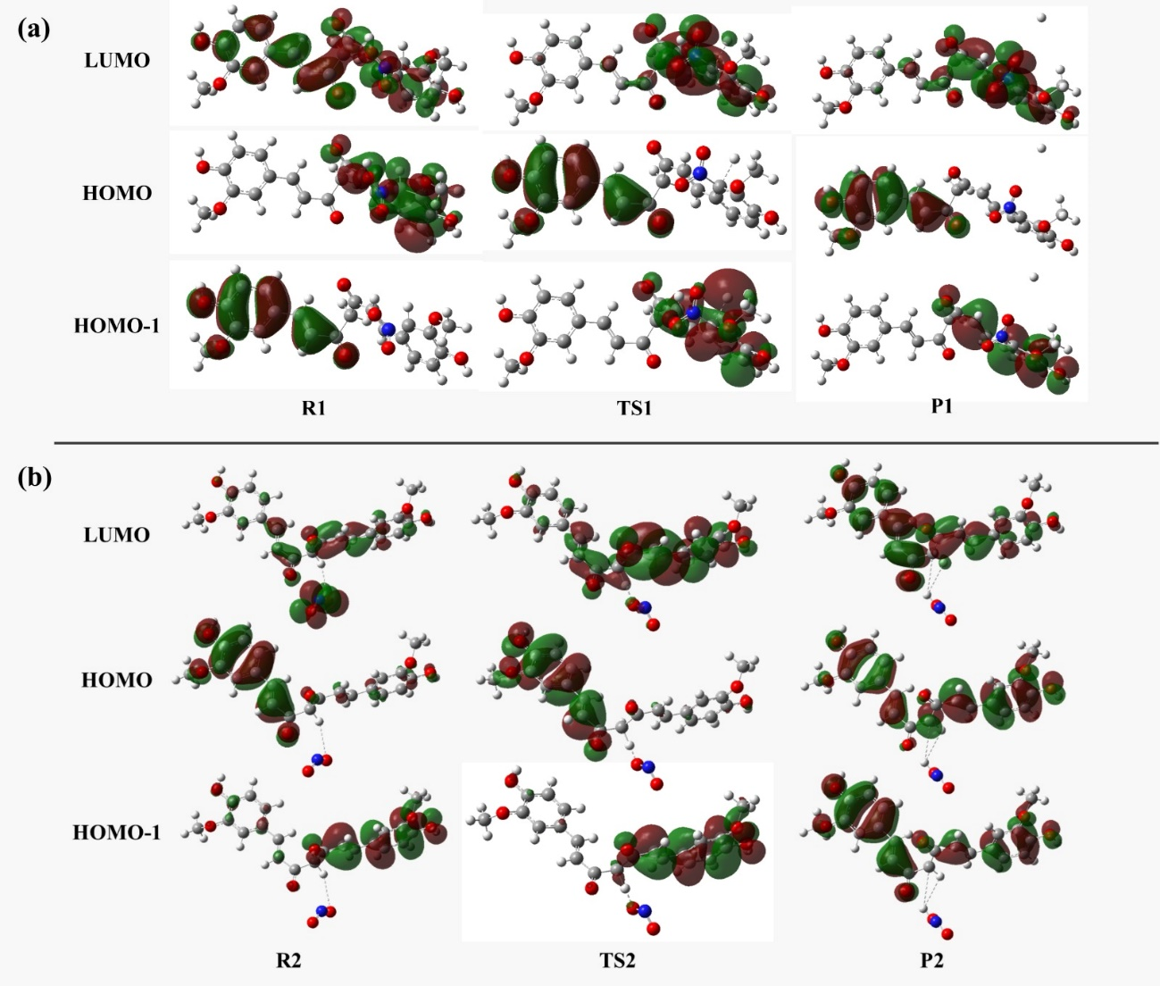

**Figure 6.** Frontier molecular orbitals for (a) reaction R1 and (b) reaction R2.

Table 1 presents the computed thermochemical data, imaginary frequencies of vibration, Gibbs free activation energies (∆‡*G*°), and activation enthalpies (∆‡*H°*) of both mechanisms obtained by combining the different methods described in section 2. All energies calculated for mechanism R1 are higher than those for R2. Therefore, mechanism R1 is slower than R2 for both temperatures.

For reaction R1, the data indicate that the M06-2X functional presents lower and values compared to B3LYP and ωB97M-V at both temperatures, suggesting that M06-2X may better describe the energy profile of the activation barrier in this system, with lower activation energy. The inclusion of diffuse functions in the basis set does not cause significant variations in the and values for the M06-2X functional. However, for ωB97M-V, the lack of diffuse functions results in slightly higher and values compared to those obtained with the diffuse functions included. For the B3LYP , the and values are smaller without diffuse functions.

For reaction R2, there is greater variability in the and values among the different functionals and basis sets. The B3LYP functional presents lower and values with the 6-311+G(d) basis set, but its sensitivity to the basis set is appreciable, showing a difference of approximately 4.2 kcal.mol⁻¹ without diffuse functions. The results for ωB97M-V, with both basis sets, are consistent, with values of approximately 36.85 kcal.mol⁻¹ (6-311G(d)) and 36.15 kcal.mol⁻¹ (6-311+G(d)). For the M06-2X functional, it predicts higher barriers than B3LYP and ωB97M-V, but shows little sensitivity to the inclusion of diffuse functions.

The reaction free energy () and reaction enthalpy () values were calculated for reactions R1 and R2 using different functionals and basis sets are presented in Table S2. For reaction R1, the M06-2X/6-311+G(d) functional showed the lowest values (32.93 kcal.mol⁻¹ at 298.15 K and 32.25 kcal.mol⁻¹ at 363.15 K). In contrast, the B3LYP functional presented the highest and values at 298.15 K. Furthermore, the inclusion of diffuse functions in the basis sets had a limited impact on the calculated values, with minimal differences between the 6-311+G(d) and 6-311G(d) basis sets for the analyzed functionals. For reaction R2, the lowest value (9.62 kcal.mol⁻¹) was obtained using the B3LYP/6-311G(d) functional. The M06-2X functional produced comparable results, with and values around 10 kcal.mol⁻¹ for both basis sets, demonstrating consistency in the outcomes. On the other hand, the wb97M-V functional showed greater variability in the and values, with values of 12.03 kcal.mol⁻¹ for the 6-311+G(d) basis set and 10.90 kcal.mol⁻¹ for the 6-311G(d) basis set.

Therefore, the functionals that showed the least sensitivity to the basis set were M06-2X for reaction R1 and ωB97M-V for reactions R1 and R2. On the other hand, the B3LYP functional showed greater variation in the and values, especially for reaction R2. These results are consistent with the literature, highlighting M06-2X as a reliable starting point for calculating the thermodynamic properties of organic radical species. Additionally, the ωB97M-V functional displayed promising performance in describing activation barriers.

Based on the results = for the energy barriers, the **M06-2X** functional was selected due to its consistent performance in the investigated reactions and lower sensitivity to the inclusion of diffuse functions compared to the others. The inclusion of diffuse functions showed minimal impact on the values calculated with M06-2X, which uses the 6-311G(d) basis set, given that its use reduces computational demand without compromising the accuracy of the results.

**Table 1.** Thermochemical data, imaginary frequencies in cm-1 of the transition states, and ∆‡*G*°and ∆‡*H*°values, in kcal.mol-1, for the reactions R1 and R2 at two different temperatures. The energy difference between the reactant and the transition state was computed in the NCL solvent.

|  |  |  |  |  |  |  |
| --- | --- | --- | --- | --- | --- | --- |
| **Reaction** | **Method** | **Imaginary Frequency** | 298.15K | | 363.15K | |
| **Δ‡G** | **Δ‡H** | **Δ‡G** | **Δ‡H** |
| **R1** | *B3LYP/6-311+G(d)* | -773.40 | 44.37 | 43.57 | 44.47 | 43.62 |
| *B3LYP/6-311G(d)* | -773.79 | 42.45 | 43.21 | 42.28 | 43.27 |
| *M06-2X/6-311+G(d)* | -943.31 | 41.70 | 41.14 | 41.82 | 41.20 |
| *M06-2X/6-311G(d)* | -937.05 | 40.85 | 41.03 | 40.59 | 41.07 |
| *wb97M-V/6-311+G(d)* | -933.15 | 42.15 | 42.23 | 42.47 | 42.90 |
| *wb97M-V/6-311G(d)* | -920.75 | 43.31 | 42.93 | 43.27 | 42.93 |
| **R2** | *B3LYP/6-311+G(d)* | -1720.82 | 31.06 | 30.97 | 35.31 | 31.54 |
| *B3LYP/6-311G(d)* | -1446.75 | 35.28 | 32.33 | 35.92 | 32.34 |
| *M06-2X/6-311+G(d)* | -1517.74 | 38.18 | 35.79 | 38.66 | 35.77 |
| *M06-2X/6-311G(d)* | -1504.66 | 38.02 | 36.29 | 37.65 | 35.77 |
| *wb97M-V/6-311+G(d)* | -1738.59 | 36.15 | 34.98 | 35.62 | 35.71 |
| *wb97M-V/6-311G(d)* | -1678.48 | 36.85 | 35.57 | 37.05 | 35.63 |

Figure 6 presents the energy profiles of mechanisms R1 and R2. The computed Gibbs free activation energies for curcumin at 363.15 K (40.59 kcal/mol in mechanism R1 and 37.65 kcal/mol in mechanism R2) are close to the experimental value of the DPA activation energy of 145.7 kJ/mol (= 34.82 kcal/mol in the 60 – 100 °C/333.15 – 373.15 K temperature range) [57]. The difference between the activation energy for curcumin in mechanism R2 and the activation energy of DPA is less than 3 kcal/mol. Moreover, the DFT/B2PLYP Gibbs free activation energy of the *N*-nitrosation reaction between DPA and HNO2 is 19.65 kcal/mol at 80 °C = 353.15 K [8]. Considering the difference between the overall stabilization barrier (34.82 kcal/mol) and the elementary reaction barrier (19.65 kcal/mol) for DPA, a stabilizer of similar effectiveness should present an elementary reaction barrier in the range of 19.65–49.99 kcal/mol. Since all barriers in Table 1 are within this range, the barrier for curcumin is similar to other widely used stabilizers. Thereby, we confirm with accurate theoretical calculations the promising effectiveness of curcumin as a stabilizer [5]. Other stabilizers corroborate our results in the 338.15–353.15 K temperature range; for instance, centralite I, whose activation energy is about 23 kcal/mol [1], and several other stabilizer substances, including mixtures, whose activation energies vary from 25 to 39 kcal/mol [12,58,59].

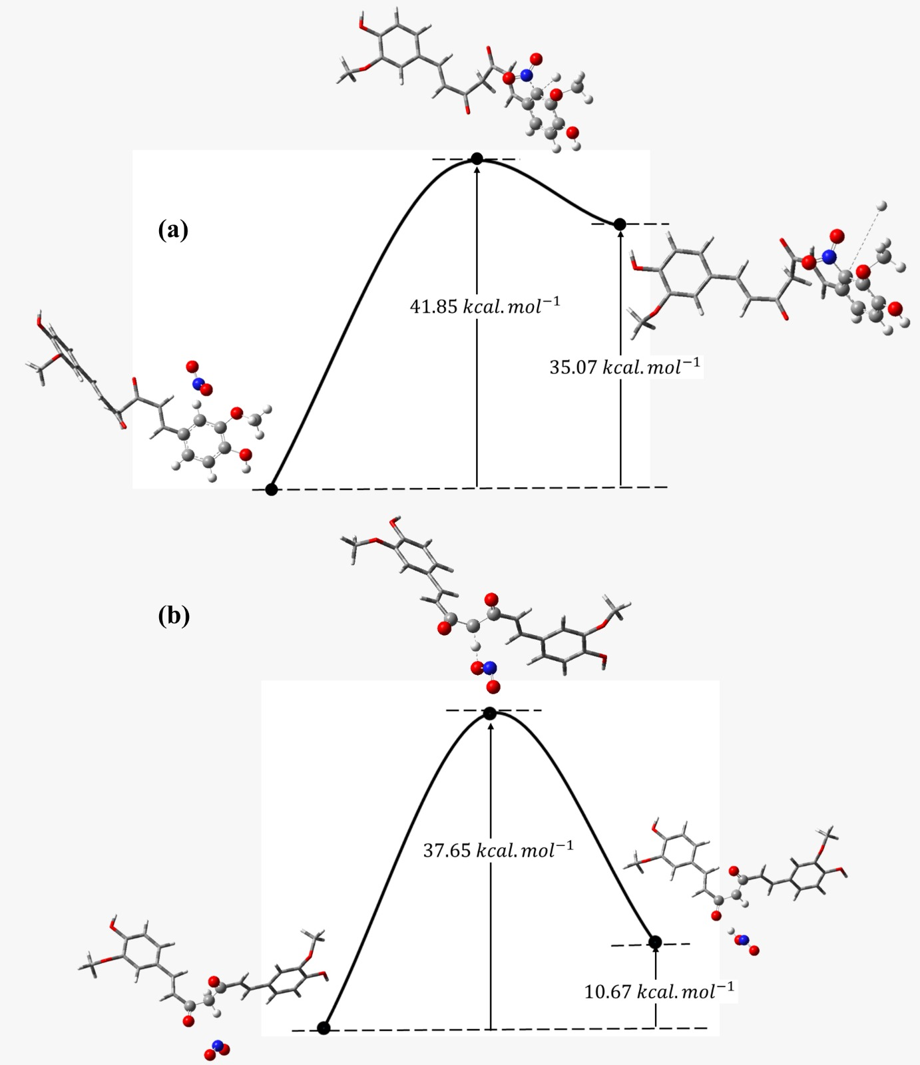

**Figure 6.** DFT/M06-2X/6-311G(d) Gibbs energy profile for mechanisms (a) R1 and (b) R2. The calculations included the NCL solvent, and the temperature was 363.15 K.

Table 2 presents the NBO charges of the atoms in a molecule in three states: reactant (R), transition state (TS), and product (P) for the two reactions. In reaction 1, the hydrogen atom (H) shows a significant decrease in charge throughout the reaction, going from 0.260*e* in R1 to nearly neutral in P1 (0.000*e*), suggesting a possible charge transfer associated with the breaking of bonds involving hydrogen. The carbon atom (C) also shows a change in charge during the process, moving from -0.141*e* in R1 to 0.079*e* in P1, which may indicate a redistribution of electron density around this atom throughout the reaction. On the other hand, the nitrogen atom (N) maintains a relatively constant charge (around 0.55e) across the three states, suggesting that it plays a more stable role in the reaction without significant changes in its electron density. There is a slight variation in charge for the oxygen atoms O1 and O2: O1 changes from -0.399*e* in R1 to -0.355*e* in P1, while O2 shows a smaller change, from -0.405*e* to -0.37*e*. These small changes in the oxygen charges indicate a subtle charge redistribution, possibly due to bonding interactions throughout the reaction. The charges for the remaining atoms are shown in Figures 2S to 4S of the Supplementary Material.

For reaction 2, the hydrogen atom (H) changes from an initial charge of 0.243*e* to 0.497*e* in the final state, indicating a gradual increase in electron density throughout the reaction. The carbon atom (C) undergoes a significant charge variation, going from -0.592*e* in the initial state to -0.14 *e* in the final state. This change reflects the redistribution of electron density during the process, which is associated with breaking the C-H bond. The nitrogen atom (N) shows a reduction in charge from 0.569*e* in the initial state to 0.337*e* in the transition state, stabilizing at 0.34*e* in the final state, confirming that N is involved in a charge transfer during the transition state. The oxygen atoms, O1 and O2, also exhibit variations in their charges, with O1 decreasing from -0.298*e* in the initial state to -0.312*e* in the final state. O2, in turn, shows a significantly more significant change, from -0.27*e e* 4 to -0.573*e*. These changes in the oxygen charges indicate a charge redistribution throughout the reaction due to the formation of the O-H bond, which affects the electron density around these atoms. The charges for the remaining atoms are shown in Figures 5S to 7S (Supplementary Material).

**Table 2**: NBO Charges of Atoms in Reactant (R), Transition State (TS), and Product (P) for the two reactions at the M06-2X/6-311G(d) level theory in units of the elementary charge *e*.

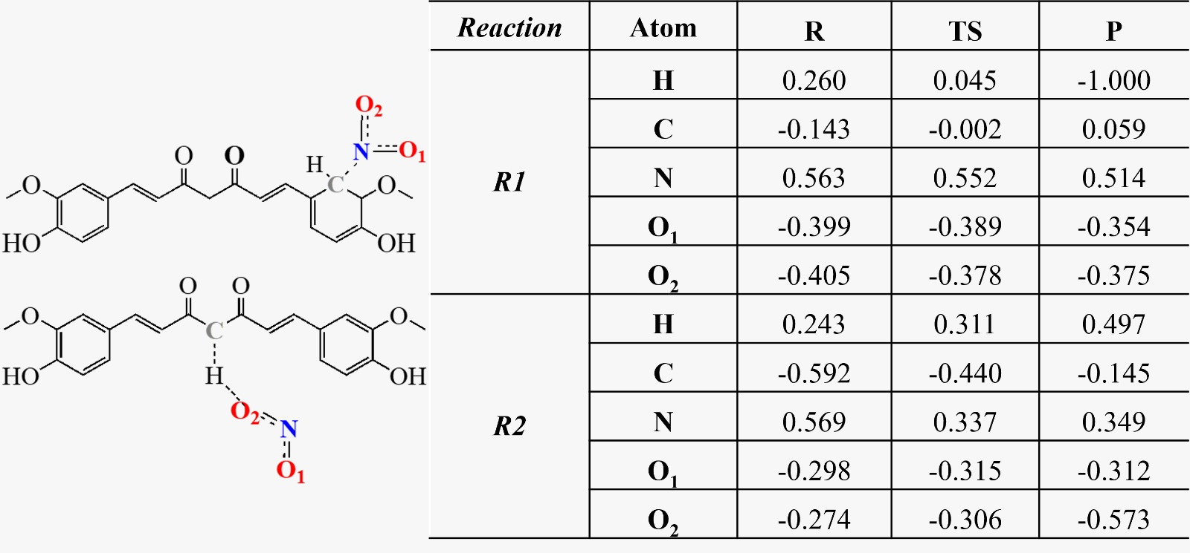

# 4 ConclusionS

DFT methods were used to investigate the reaction of NO2 with the green stabilizer curcumin. We identified two plausible mechanisms that agree with similar mechanisms proposed for other widely used stabilizers. The results show that curcumin can capture NO2, highlighting its use as a stabilizer in NC-based propellants, with the advantage of being a green substance. Moreover, our results indicate the energetic similarity between curcumin and other widely stabilizers (diphenylamine, centralite I, and centralite II) since the energy barriers of other stabilization reactions and the energy barriers of reactions between curcumin and NO2 have similar values.

In this work, we found that the M06-2X functional had superior performance for reaction R1, presenting the lowest , , and values, along with minimal sensitivity to the inclusion of diffuse functions, making it a robust choice for modeling activation barriers. For reaction R2, B3LYP/6-311G(d) produced the lowest value, but its higher sensitivity to the basis set suggests it may require careful validation. The ωB97M-V functional showed consistency across reactions, albeit with slightly higher variability in some cases, indicating its potential for broader applications. These results agree with existing literature, reinforcing the reliability of M06-2X for studying thermodynamic properties of organic radical species while highlighting the applicability of ωB97M-V for reaction profile analysis.

The NBO charge analysis highlights significant electronic changes across the reactant, transition state, and product for both reactions. In reaction 1, there is a decrease in the hydrogen atom's charge, coupled with the redistribution of electron density around the carbon atom, indicating the breaking of bonds involving hydrogen during the reaction. The nitrogen atom remains relatively stable, while the oxygen atoms exhibit subtle charge variations, reflecting minor electron density shifts. For reaction 2, the hydrogen and carbon atoms show pronounced changes in charge values, confirming the breaking of the C-H bond and electron-density redistribution. The nitrogen atom's charge decreases during the transition state, suggesting its involvement in charge transfer. In contrast, the oxygen atoms undergo significant variations, particularly O2, due to the formation of the O-H bond. These observations provide insights into the electronic rearrangements driving the reaction mechanisms.

Other mechanisms related to NC stabilization by curcumin could be investigated. Future works could study the step following R2, nitration on the central carbon, resembling the *N*-nitrosation in DPA. Similar to DPA, the curcumin molecule could be nitrated more than once and react similarly with nitro compounds in a multi-step mechanism. For instance, nitration in the aromatic ring can occur, followed by the removal of the hydrogen of the central carbon, thus resembling the mechanisms R1 and R2. Furthermore, considering that the curcumin molecule has more atoms than DPA, with other unsaturations apart from those in the aromatic rings, there are other possibilities for the electrophilic attack by NO2. Although we did not investigate these possibilities in this work, we confirmed experimental data on the stabilization properties of curcumin with theoretical results for the first time. Using curcumin as a green stabilizer is a significant advance in the long-term storage safe of propellants because it is a less pollutant substance. Our work confirmed this role with accurate DFT calculations.

# 5 Acknowledgments

I. B. thanks the Brazilian agencies CNPq (Grant numbers 304148/2018-0 and 409447/2018-8) and FAPERJ (Grant number E26/201.197/2021) for support of this research. J. N. also thanks FAPERJ (Grant numbers E-26/201.251/2022, E-26/211.046/2021, E-26/210.067/2021) for financial support. We are grateful for the discussions with Prof. Gustavo Rocha Silva. Nathália M. P. Rosa thanks FAPERJ (grant number E-26/205.922/2022) for a post-doctoral scholarship.

**Additional Supporting Information**. The data supporting this study's findings are available in this article's supplementary material, which includes detailed tables with thermodynamic data, NBO charges for all atoms, and the 3D structures of transition states. Additional data, including input and output files of the calculations and a spreadsheet with the results, are available in the our GitHub and can be accessed via https://github.com/Quimica-Teorica-IME/Curcumin_in_nitrocellulose-based_propellants.

# References

1. Teixeira FP, Anastacio AC, de Mendonça-Filho LG, Nichele J (2023) Effect of relative humidity and absorbed water on the ethyl centralite consumption in nitrocellulose-based propellants. Cellulose 30 (3):1411-1420. doi:10.1007/s10570-022-04999-4

2. Defanti BFdS, Mendonça-Filho LGd, Nichele J (2020) Effect of ageing on the combustion of single base propellants. Combust Flame 221:212-218. doi:<https://doi.org/10.1016/j.combustflame.2020.07.029>

3. Dejaifve A, Berton V, Dobson R (2016) Stabilized nitrocellulose-based propellant composition. USA Patent,

4. Klapötke TM (2023) The Future of Synthesis Chemistry in Energetics. Propellants, Explosives, Pyrotechnics 48 (3):e202380331. doi:<https://doi.org/10.1002/prep.202380331>

5. Rodrigues RLB, Gomes Buitrago PA, Nakano NL, Peixoto FC, Lemos MF, França TCC, Mendonça Filho LG (2022) Can green nitrocellulose-based propellants be made through the replacement of diphenylamine by the natural product curcumin? J Energ Mater 40 (2):218-241. doi:10.1080/07370652.2020.1859646

6. Liu J, Dai J, Wang S, Peng Y, Cao L, Liu X (2020) Facile synthesis of bio-based reactive flame retardant from vanillin and guaiacol for epoxy resin. Composites Part B: Engineering 190:107926. doi:<https://doi.org/10.1016/j.compositesb.2020.107926>

7. Rodrigues RLB, Nichele J, França TCC, Mendonça Filho LG (2018) Prediction of toxicity of the usual stabilizers in nitrocellulose based propellants and their main degradation produc. Química Nova 41

8. do Nascimento Mossri JL, Rodrigues RLB, Nichele J, Borges I Nitrocellulose-based propellants: elucidation of the mechanisms of the diphenylamine stabilizer employing density functional theory. J Energ Mater:1-19. doi:10.1080/07370652.2023.2168312

9. Dejeaifve A, Fantin A, Monseur L, Dobson R (2018) Making Progress Towards «Green» Propellants. Propellants, Explosives, Pyrotechnics 43 (8):831-837. doi:<https://doi.org/10.1002/prep.201800026>

10. Luo L, Jin B, Xiao Y, Zhang Q, Chai Z, Huang Q, Chu S, Peng R (2019) Study on the isothermal decomposition kinetics and mechanism of nitrocellulose. Polymer Testing 75:337-343. doi:<https://doi.org/10.1016/j.polymertesting.2019.02.024>

11. Krumlinde P, Ek S, Tunestål E, Hafstrand A (2017) Synthesis and Characterization of Novel Stabilizers for Nitrocellulose-Based Propellants. Propellants, Explosives, Pyrotechnics 42 (1):78-83. doi:<https://doi.org/10.1002/prep.201600122>

12. Trache D, Tarchoun AF (2018) Stabilizers for nitrate ester-based energetic materials and their mechanism of action: a state-of-the-art review. J Mater Sci 53 (1):100-123. doi:10.1007/s10853-017-1474-y

13. Mendonça-Filho LG, Rodrigues RLB, Rosato R, Galante EBF, Nichele J (2019) Combined evaluation of nitrocellulose-based propellants: toxicity, performance, and erosivity. J Energ Mater 37 (3):293-308. doi:10.1080/07370652.2019.1606867

14. Ruby AJ, Kuttan G, Dinesh Babu K, Rajasekharan KN, Kuttan R (1995) Anti-tumour and antioxidant activity of natural curcuminoids. Cancer Letters 94 (1):79-83. doi:<https://doi.org/10.1016/0304-3835(95)03827-J>

15. Folly P, Mäder P (2004) Propellant Chemistry. CHIMIA 58 (6):374. doi:10.2533/000942904777677713

16. Itkis DG, Bohn MA (2021) Simulation of Heat Flow Curves of NC-Based Propellants – Part 1: Determination of Reaction Enthalpies and Other Characteristics of the Reactions of NC and Stabilizer DPA Using Quantum Mechanical Methods. Propellants, Explosives, Pyrotechnics 46 (8):1188-1203. doi:<https://doi.org/10.1002/prep.202000314>

17. Itkis DG, Bohn MA (2021) Simulation of Heat Flow Curves of NC-Based Propellants – Part 2: Application to DPA Stabilized Propellants. Propellants, Explosives, Pyrotechnics 46 (8):1204-1215. doi:<https://doi.org/10.1002/prep.202000313>

18. Lussier LS, Gagnon H, Bohn MA (2000) On the Chemical Reactions of Diphenylamine and its Derivatives with Nitrogen Dioxide at Normal Storage Temperature Conditions. Propellants, Explosives, Pyrotechnics 25 (3):117-125. doi:<https://doi.org/10.1002/1521-4087(200006)25:3><117::AID-PREP117>3.0.CO;2-8

19. Vollhardt P (2018) Organic Chemistry: Structure and Function. 8th edn. W. H. Freeman, New York

20. Omlor A, Bohm ML (2021) Enthalpies of Formation for a Selection of Newer and Conventional Stabilizers and Reaction Enthalpies for their Stabilization Action in Nitrocellulose. Paper presented at the 51st International Annual Conference of the Fraunhofer ICT, Energetic Materials – Exploring and Understanding, Karlsruhe, Germany, 2022

21. Liu C-W, Peng C-H, Liu M-H (2024) Theoretical investigation on action mechanism and mollifying efficacy of propellant stabilizers. J Mol Model 30 (5):130. doi:10.1007/s00894-024-05919-y

22. Sun Z-D, Fu X-L, Yu H-J, Fan X-Z, Ju X-H (2017) Theoretical study on stabilization mechanisms of nitrate esters using aromatic amines as stabilizers. J Hazard Mater 339:401-408. doi:<https://doi.org/10.1016/j.jhazmat.2017.06.025>

23. Kong L, Dong K, Li G, Yang C, Lai S, Qu Y (2022) Molecular simulation study on the protective mechanism of three kinds of HTPB propellant antioxidants. FirePhysChem 2 (1):4-13. doi:<https://doi.org/10.1016/j.fpc.2022.03.003>

24. Borges I (2008) Conformations and charge distributions of diazocyclopropanes. International Journal of Quantum Chemistry 108 (13):2615-2622. doi:10.1002/qua.21671

25. Anders G, Borges I (2011) Topological analysis of the molecular charge density and impact sensitivy models of energetic molecules. J Phys Chem A 115 (32):9055-9068. doi:10.1021/jp204562d

26. Giannerini T, Borges I (2015) Molecular electronic topology and fragmentation onset via charge partition methods and nuclear fukui functions: 1,1-diamino-2,2-dinitroethylene. J Braz Chem Soc 26 (5):851-859. doi:10.5935/0103-5053.20150044

27. Oliveira MAS, Borges I (2019) On the molecular origin of the sensitivity to impact of cyclic nitramines. International Journal of Quantum Chemistry 119 (8):14. doi:10.1002/qua.25868

28. de Oliveira RSS, Borges I (2019) Correlation between molecular charge densities and sensitivity of nitrogen-rich heterocyclic nitroazole derivative explosives. J Mol Model 25 (10):314. doi:10.1007/s00894-019-4195-0

29. Oliveira MAS, Oliveira RSS, Borges I (2021) Quantifying bond strengths via a Coulombic force model: application to the impact sensitivity of nitrobenzene, nitrogen-rich nitroazole, and non-aromatic nitramine molecules. J Mol Model 27 (3):69. doi:10.1007/s00894-021-04669-5

30. Siqueira Soldaini Oliveira R, Borges Jr. I (2021) Correlation Between Molecular Charge Properties and Impact Sensitivity of Explosives: Nitrobenzene Derivatives. Propellants, Explosives, Pyrotechnics 46 (2):309-321. doi:<https://doi.org/10.1002/prep.202000233>

31. Borges I, Oliveira RSS, Oliveira MAS (2022) Chapter 4 - Properties of molecular charge distributions affecting the sensitivity of energetic materials. In: Mathieu D (ed) Theoretical and Computational Chemistry, vol 22. Elsevier, pp 81-105. doi:10.1016/B978-0-12-822971-2.00013-9

32. Duarte JC, da Rocha RD, Borges I (2023) Which molecular properties determine the impact sensitivity of an explosive? A machine learning quantitative investigation of nitroaromatic explosives. Phys Chem Chem Phys 25 (9):6877-6890. doi:10.1039/D2CP05339J

33. Borges I (2008) Excited electronic and ionized states of N,N-dimethylnitramine. Chem Phys 349:256-262

34. BORGES I (2008) Excited electronic and ionized states of N,N-dimethylnitramine. Chem Phys 349 (1-3):256-262. doi:10.1016/j.chemphys.2008.02.043

35. BORGES I (2008) Excited electronic and ionized states of the nitramide molecule, H2NNO2, studied by the symmetry-adapted-cluster configuration interaction method. Theor Chem Acc 121 (5-6):239-246. doi:10.1007/s00214-008-0469-9

36. Borges I, Aquino A, Barbatti M, Lischka H (2009) The Electronically Excited States of RDX (hexahydro-1,3,5-trinitro-1,3,5-triazine): Vertical Excitations. International Journal of Quantum Chemistry 109 (11):2348-2355. doi:10.1002/qua.22043

37. Borges I, Barbatti M, Aquino AJA, Lischka H (2012) Electronic spectra of nitroethylene. International Journal of Quantum Chemistry 112 (4):1225-1232. doi:10.1002/qua.23080

38. Borges I, Aquino AJA, Lischka H (2014) A Multireference Configuration Interaction Study of the Photodynamics of Nitroethylene. J Phys Chem A 118 (51):12011-12020. doi:10.1021/jp507396e

39. NATO Allied Ordnance Publication (NATO AOP) (2007). vol 48, 2 edn., Brussels, Belgium

40. Frisch MJ, Trucks GW, Schlegel HB, Scuseria GE, Robb MA, Cheeseman JR, Scalmani G, Barone V, Mennucci B, Petersson GA, Nakatsuji H, Caricato M, Li X, Hratchian HP, Izmaylov AF, Bloino J, Zheng G, Sonnenberg JL, Hada M, Ehara M, Toyota K, Fukuda R, Hasegawa J, Ishida M, Nakajima T, Honda Y, Kitao O, Nakai H, Vreven T, Montgomery Jr. JA, Peralta JE, Ogliaro F, Bearpark MJ, Heyd J, Brothers EN, Kudin KN, Staroverov VN, Kobayashi R, Normand J, Raghavachari K, Rendell AP, Burant JC, Iyengar SS, Tomasi J, Cossi M, Rega N, Millam NJ, Klene M, Knox JE, Cross JB, Bakken V, Adamo C, Jaramillo J, Gomperts R, Stratmann RE, Yazyev O, Austin AJ, Cammi R, Pomelli C, Ochterski JW, Martin RL, Morokuma K, Zakrzewski VG, Voth GA, Salvador P, Dannenberg JJ, Dapprich S, Daniels AD, Farkas Ö, Foresman JB, Ortiz JV, Cioslowski J, Fox DJ (2009) Gaussian 09, Revision A.02. Gaussian, Inc., Wallingford, CT, USA

41. Neese F (2022) Software update: The ORCA program system—Version 5.0. WIREs Computational Molecular Science 12 (5):e1606. doi:<https://doi.org/10.1002/wcms.1606>

42. Lee C, Yang W, Parr RG (1988) Development of the Colle-Salvetti correlation-energy formula into a functional of the electron density. Phys Rev B: Condens Matter Mater Phys 37:785

43. Becke AD (1993) Density-functional thermochemistry. III. The role of exact exchange. J Chem Phys 98 (7):5648

44. Krishnan R, Binkley JS, Seeger R, Pople JA (1980) Self‐consistent molecular orbital methods. XX. A basis set for correlated wave functions. The Journal of Chemical Physics 72 (1):650-654. doi:10.1063/1.438955

45. Neese F (2003) An improvement of the resolution of the identity approximation for the formation of the Coulomb matrix. Journal of Computational Chemistry 24 (14):1740-1747. doi:<https://doi.org/10.1002/jcc.10318>

46. Neese F (2012) The ORCA program system. WIREs Computational Molecular Science 2 (1):73-78. doi:<https://doi.org/10.1002/wcms.81>

47. Helmich-Paris B, de Souza B, Neese F, Izsák R (2021) An improved chain of spheres for exchange algorithm. The Journal of Chemical Physics 155 (10). doi:10.1063/5.0058766

48. Bursch M, Mewes J-M, Hansen A, Grimme S (2022) Best-Practice DFT Protocols for Basic Molecular Computational Chemistry**. Angewandte Chemie International Edition 61 (42):e202205735. doi:<https://doi.org/10.1002/anie.202205735>

49. Mardirossian N, Head-Gordon M (2016) ωB97M-V: A combinatorially optimized, range-separated hybrid, meta-GGA density functional with VV10 nonlocal correlation. The Journal of Chemical Physics 144 (21). doi:10.1063/1.4952647

50. Zhao Y, Truhlar DG (2008) The M06 suite of density functionals for main group thermochemistry, thermochemical kinetics, noncovalent interactions, excited states, and transition elements: two new functionals and systematic testing of four M06-class functionals and 12 other functionals. Theor Chem Acc 120 (1):215-241. doi:10.1007/s00214-007-0310-x

51. Liptak MD, Shields GC (2001) Accurate pKa Calculations for Carboxylic Acids Using Complete Basis Set and Gaussian-n Models Combined with CPCM Continuum Solvation Methods. J Am Chem Soc 123 (30):7314-7319. doi:10.1021/ja010534f

52. Marenich AV, Cramer CJ, Truhlar DG (2009) Universal Solvation Model Based on Solute Electron Density and on a Continuum Model of the Solvent Defined by the Bulk Dielectric Constant and Atomic Surface Tensions. The Journal of Physical Chemistry B 113 (18):6378-6396. doi:10.1021/jp810292n

53. Winget P, Dolney D, Giesen D, Cramer C, Truhlar D (1999) Minnesota Solvent Descriptor Database.

54. Johansson MP, Kaila VRI, Sundholm D (2013) Ab Initio, Density Functional Theory, and Semi-Empirical Calculations. In: Monticelli L, Salonen E (eds) Biomolecular Simulations: Methods and Protocols. Humana Press, Totowa, NJ, pp 3-27. doi:10.1007/978-1-62703-017-5_1

55. Lewis DE (1999) Organizing Organic Reactions: The Importance of Antibonding Orbitals. J Chem Educ 76 (12):1718. doi:10.1021/ed076p1718

56. Murakami M, Tanaka K (2021) How to explain an S<sub>N</sub>2 reaction? Journal of Synthetic Organic Chemistry, Japan 79 (11):1073-1076. doi:10.5059/yukigoseikyokaishi.79.1073

57. Bohn MA, Volk F (1992) Aging Behavior of Propellants investigated by heat generation, stabilizer consumption, and molar mass degradation. Propellants, Explosives, Pyrotechnics 17 (4):171-178. doi:<https://doi.org/10.1002/prep.19920170405>

58. Fengqi Z, Shuyun H, Rongzu H, Hongxu G, Fang H (2007) A study of kinetic behaviours of the effective centralite/stabilizer consumption reaction of propellants using a multi-temperature artificial accelerated ageing test. J Hazard Mater 145 (1):45-50. doi:<https://doi.org/10.1016/j.jhazmat.2006.10.085>

59. Li J, Tian T, Zhang G, Liu Z, Gu Z, Niu J (2021) Reaction Model for the Aging and Shelf-Life Prediction of Double-Base Propellant SF-3. Propellants, Explosives, Pyrotechnics 46 (6):986-994. doi:<https://doi.org/10.1002/prep.202100017>